Report form for late reported test results

The sample is a bracelet and can be divided into two different parts:

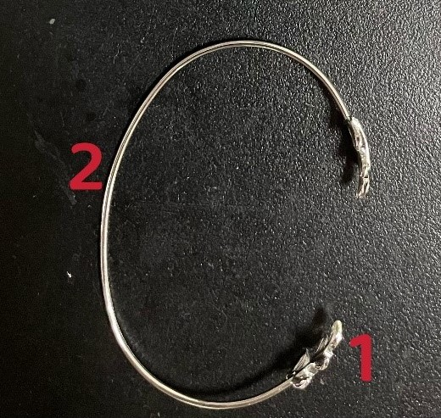
Bracelet, divided into two different parts:

#23630-1: Decoration of the bracelet (leaves)
#23630-2: Main part of the bracelet

Please report the test results for the different parts separately. Determinations on the decoration of the bracelet (leaves) can be reported in sample #23630-1 and determinations on the main part of the bracelet can be reported in sample #23630-2. It is not obligated to test both parts of the bracelet. In case you test only one of the parts, please be sure to report the test results in the appropriate sample. If your normal determination routine is any different than described as above then please explain this routine in the comments.

This report form continues on the next page.

Report form for late reported test results

Sample #23630-1: Decoration of the bracelet (leaves)
Determination | Unit | Reference  method *) | Actual method used *) | ’Unrounded’  result *) | Rounded  result cfr. used standard *)
Antimony as Sb, total | mg/kg
Arsenic as As, total | mg/kg
Cadmium as Cd, total | mg/kg
Chromium as Cr, total | mg/kg
Cobalt as Co, total | mg/kg
Copper as Cu, total | mg/kg
Lead as Pb, total | mg/kg
Manganese as Mn, total | mg/kg
Mercury as Hg, total | mg/kg
Nickel as Ni, total | mg/kg
Selenium as Se, total | mg/kg
Strontium as Sr, total | mg/kg
Tin as Sn, total | mg/kg
Zinc as Zn, total | mg/kg
Zirconium as Zr, total | mg/kg
*) Please see the letter of instructions before the start of the tests at www.kpmd.co.uk/sgs-iis-cts

Comments:

This report form continues on the next page.

Report form for late reported test results

Sample #22630-2: Main part of the bracelet
Determination | Unit | Reference  method *) | Actual method used *) | ’Unrounded’  result *) | Rounded  result cfr. used standard *)
Antimony as Sb, total | mg/kg
Arsenic as As, total | mg/kg
Cadmium as Cd, total | mg/kg
Chromium as Cr, total | mg/kg
Cobalt as Co, total | mg/kg
Copper as Cu, total | mg/kg
Lead as Pb, total | mg/kg
Manganese as Mn, total | mg/kg
Mercury as Hg, total | mg/kg
Nickel as Ni, total | mg/kg
Selenium as Se, total | mg/kg
Strontium as Sr, total | mg/kg
Tin as Sn, total | mg/kg
Zinc as Zn, total | mg/kg
Zirconium as Zr, total | mg/kg
*) Please see the letter of instructions before the start of the tests at www.kpmd.co.uk/sgs-iis-cts

Comments:

Please see the next page for the Additional Questions.

Report form for late reported test results

Additional Questions

- Is your laboratory accredited in accordance with ISO/IEC17025 to determine the reported element(s)?

0 No

0 Yes

- How many grams of sample intake was used?

- Which acid was used for the digestion?

- What was the concentration (in %V/V) of the acid solution?

- Which analyze technique was used to quantify the metals?

0 ICP-OES

0 ICP-AES

0 ICP-MS

0 UV-VIS

0 AAS

0 XRF

0 Other, please mention: _____________________________________________________________

6. Remarks on Additional Questions:

